 

**INTERNSHIP REPORT**

***A report submitted in partial fulfilment of the requirements for the Award of Degree of***

**BACHELOR OF TECHNOLOGY**

**In**

**PETROLEUM ENGINEERING**

**By**

**Md.Merajuddin Ahmed**

**2nd Year Petroleum Engineering Undergraduate**

**IIT(ISM) Dhanbad**

**Under Supervision of**

**Dr. Amit Kumar,**

**Assistant Professor**

**Rajiv Gandhi Institute of Petroleum Technology, Jais, Amethi,**

**(Duration: 7th June, 2024 to 19th July, 2023)**

**DEPARTMENT OF PETROLEUM ENGINEERING AND GEO-ENGINEERING**

**RAJIV GANDHI INSTITUTE OF PETROLEUM TECHNOLOGY**

**AMETHI, UTTAR PRADESH**

ACKNOWLEDGEMENT

I would like to express my sincere gratitude to the Rajiv Gandhi Institute of Petroleum Technology (RGIPT) for providing me with the opportunity to undertake my internship at their esteemed institution. The experience and knowledge I gained during this internship have been invaluable in shaping my understanding of the field of petroleum technology and enhancing my professional growth.

I am deeply indebted to my supervisor, Dr. Amit Kumar, Assistant Professor at RGIPT, for his guidance, support, and mentorship throughout my internship. His expertise, insightful feedback, and constructive suggestions played a pivotal role in shaping the direction and quality of my work. I am truly grateful for his unwavering support and encouragement.

I would also like to express my gratitude to Ph.D. students Anas Azeem and Anil for their assistance and collaboration throughout my internship. Their contributions, whether through discussions or data analysis, were truly valuable and greatly enriched my internship experience. I appreciate their willingness to share their expertise and insights, which significantly enhanced the quality of my work.

Lastly, I would like to express my heartfelt appreciation to my family and friends for their unwavering support and encouragement during this internship. Their belief in my abilities and their constant motivation played a crucial role in my success.

Abstract

This report details the experience and findings from a two-month research internship at the Rajiv Gandhi Institute of Petroleum Technology (RGIPT), where I had the opportunity to enhance my technical skills and apply them to a significant industry-relevant project. During the first two weeks of the internship, I was introduced to the complexities of CMG software, a leading tool in reservoir simulation. Under the guidance of experienced PhD students, I gained proficiency in utilizing the software, which is crucial for modelling and analysing reservoir behaviour.

The internship provided a comprehensive learning experience, beginning with the foundational aspects of CMG software, including its interface, functionalities, and key features. The mentorship from PhD students was instrumental in navigating the initial learning curve, allowing me to quickly become adept at using the software for advanced simulations. This foundational knowledge was essential for the subsequent phase of my internship, where I undertook a project focused on waterflooding.

For the remaining duration of the internship, I dedicated my efforts to a project that explored the intricacies of waterflooding in reservoir engineering. This project involved using CMG software to model waterflooding scenarios and assess their impact on reservoir performance. The analysis underscored the critical importance of waterflooding as an enhanced oil recovery technique, highlighting its significant role in maximizing hydrocarbon recovery and optimizing reservoir management.

The culmination of this internship has significantly enhanced my understanding of reservoir simulation and waterflooding processes. The hands-on experience with CMG software and the practical insights gained through the project underscore the vital role of simulation tools in the petroleum industry. This internship not only refined my technical skills but also provided a deeper appreciation of the complexities involved in reservoir management and enhanced oil recovery techniques.

Index

Introduction………………………………………………………………………… 5

CMG Software………………………………………………………………………6

Sections in Builder…………………………………………………………………..9

Reservoir Section…………………………………………………………………..10

Components Section……………………………………………………………….15

Rock Fluid Section………………………………………………………………...15

Initial Condition…………………………………………………………………...16

Wells and Recurrent………………………………………………………………17

I/O Control……………………………………………………………………......18

Different Recovery Mechanism………………………………………………......20

Water flooding in Oil Reservoir………………………………………………….22

Case Study…………………………………………………………………….….24

Grid Sensitivity Analysis………………………………………………………....31

Deciding time of Water Injection………………………………………………...32

Deciding how much should be injected………………………………….………33

Comparing efficiency of 5 spot v/s 7spot……………………………………..…35

Conclusion: Comparing sweep efficiency of 5 spot, 7 spot and 9 spot patterns…………………………………………………………………………...36

Introduction

**What is Reservoir Simulation**?

Reservoir simulation involves constructing and operating a mathematical model that copies the behaviour of an actual oil or gas reservoir. This model will show fluid flow, rock properties, and reservoir geometry. Although the model lacks the physical reality of the reservoir, its behaviour simulates and assumes the appearance of the actual reservoir.

**What do we use reservoir modelling for?**

As the name suggests we simulate the reservoir to see how it will perform under various circumstances. When operating a field, a lot of decisions have to be made. For example:

Where to place the production wells for optimum recovery?

When to start 2ndary recovery?

Which recovery mechanism is the optimum economically?

When to stop 2ndary recovery?

What parameters we can change to improve recovery? Etc.

Reservoir Simulation is a very effective way to take these decisions in a cost-effective way.

For my project I have used the software made by CMG.

CMG Software

Computer Modelling Group Ltd, abbreviated as CMG, is a software company that produces reservoir simulation software for the oil and gas industry.

The company offers three reservoir simulation applications:

1.**IMEX**: a conventional black oil simulator used for primary, secondary recovery processes (like water and gas injection).

2. **GEM**: an advanced Equation-of-State (EoS) compositional and unconventional simulator. Used for EOR, and retrograde gas plus volatile oil reservoir.

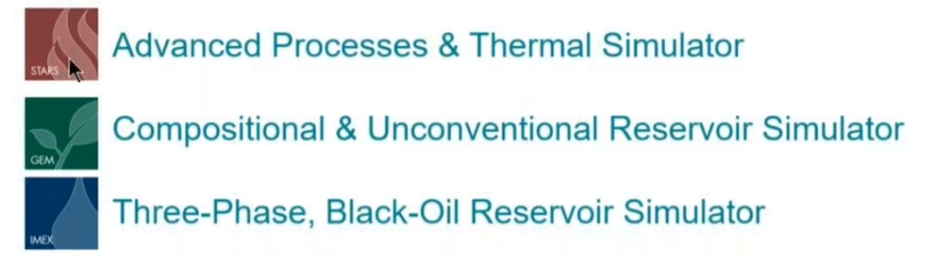3. **STARS**: a k-value thermal and advanced processes simulator. Specially used for thermal EOR.

**Fig:** **Different types of simulators in CMG**

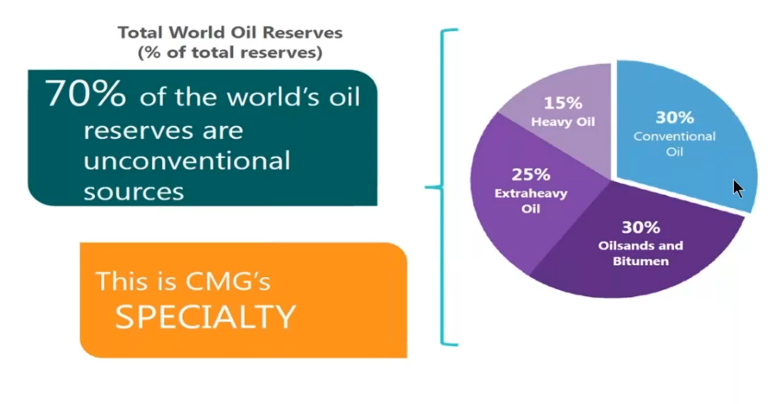The speciality of this software is that it caters to both conventional and unconventional reservoirs. And as you can see in Fig below most of the oils in the world are unconventional in nature.

**Fig: Speciality of CMG**

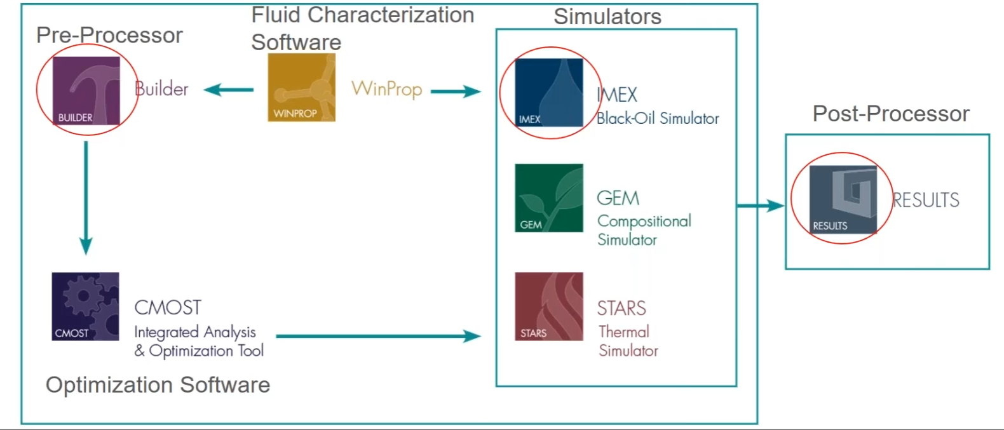

**Fig: common work flow of the software.**

**Builder** is the pre-processor in which we design and prepare simulation models for all the CMG simulators. It has an interactive interface which users take use of to make a model of their own.

**Win-prop** is a phase behaviour and fluid characterisation application. It is a pre-processor but at the same time it is a simulator as well. It helps us tune our reservoir’s Equation of State using the fluid properties. It has different ways to solve equations for IMEX, GEM and STARS

**C-Most** is an optimisation tool that we mainly use in History matching. Manually history matching is a very tedious task, using C-Most makes the process very simple.

**Results** is a post processing tool that we use to visualise and analyse the results of the simulation. We can see properties like viscosity, saturation, pressure, recovery, and many other factors variation with time.

|  |  |  |
| --- | --- | --- |
| Imex | Gem | Stars |
| Solves Fluid flow equation | It solves fluid flow equation and EOS | It solves fluid flow equation and Energy equation |
| * It does not care about the individual components. * It calculates properties like specific gravity of oil and gas, and formation volume factor of oil and gas which are phase properties (of oil and gas). Using these phase properties using the Black Oil Model we find out the flow equations. | * It cares about the individual components. For example, if there is C1, C2, C3, C4, etc, we need to input the composition of these compounds. * Using the individual compositions, we can calculate the mole fraction of C1 in oil phase and gas phase and so on for C2, C3 etc. This we do this by using EOS. And finally, when we know the accurate composition of oil and gas, we can calculate the phase properties and finally fluid flow equation. | * Similarly, like Gem it also cares about the composition. * It handles the compositional analysis using k-values and once we know mole fraction of C1 in oil and gas phase and so on we use these component properties to calculate fluid flow equations.   K-value = Yc1/Xc1  So we have k-value tables at different pressure and temperature using which we calculate the individual mole fractions. |

In my internship I mainly learnt how to use specific parts of Builder, IMEX and Results. Now I will talk about specific parts of Builder.

SECTIONS IN BUILDER

Builder has 8 sections. Each section has a specific purpose. Each of these specific purposes has been shown in the figure. Regarding the builder software you need to know that, there is a green tick or red cross, or warning sign.

**Green tick**: meaning everything inside that section that is required for the software to make calculations have been properly mentioned and you can move ahead.

**Red cross**: Either you have not done anything in that section or there is some critical data missing.

**Warning Sign**: There is some data which is ambiguous but mostly all the important information has been provided.

Note: Green Tick doesn’t mean that all the information has been given to you rather it just means all the information required for the software to carry out the calculation is given to it.

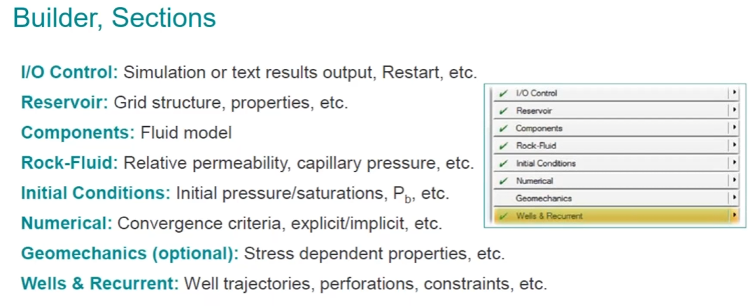

**Fig: common sections of the software.**

Now let’s talk about all the individual sections in more detail.

Reservoir Section

It considers all the aspects related to geological data and reservoir properties. Builder integrates all the static and dynamic properties (like geophysics, geology and petrophysics) to construct a reservoir model.

It mainly has two major sections that we are concerned about:

1. Reservoir Structure: Tops, layers and faults
2. Reservoir Properties: Different geological properties such as porosity, permeability and water distribution.

**Reservoir Structure**

There are different kinds of grids that can be created inside builder:

1. Cartesian

Blocks are rectangular in shape. As you can see in the top and side view of the blocks. For making this grid you mainly need to mention the dimensions of the grid and the number of grids present in the I, J, K direction. As you can see in the figure below this is how a cartesian grid would look like. This kind of grid system would be mainly used in the case of accessing and trying to study a particular zone inside the reservoir.

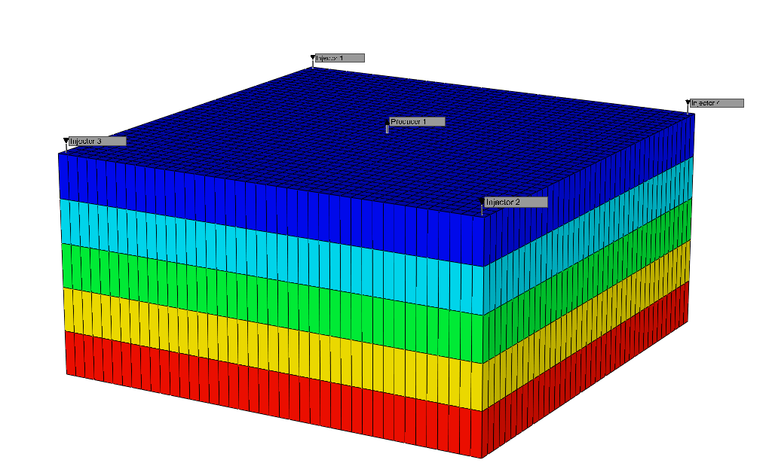

**Fig: Top and side view**

**Fig: cartesian grid reservoir**

1. Corner Point Grid

Now a block has 8 corners, so we assign the 8 coordinates of the grid and so on for all the other grids.

There are basically two kinds of grid systems:

1. Orthogonal corner point grid
2. Non-orthogonal corner point grid

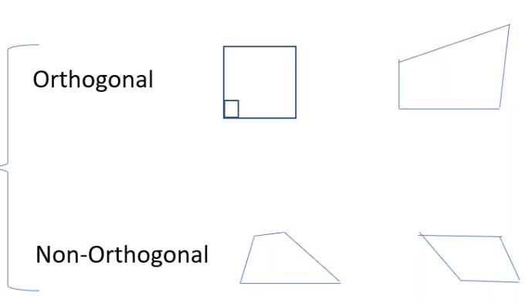 In the below figure you can see the top and side view of the respective corner point grids.

**Fig: Top and side view of corner point grid**

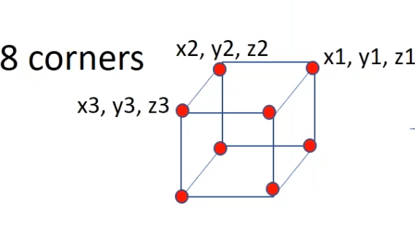

**Fig: Eight corners of corner point grid**

Since we are defining the corner point, the grid can be of any shape. If you look at the orthogonal grid from the top it looks like a square but from the side view it can take any shape. As for the non-orthogonal grid system it can take any shape from both the top and side view.

This is very useful because we are dealing with a real-world reservoir which will have curved surfaces, and this grid system is properly able to replicate it.

1. Radial: This is mainly used to model near well bore effects like condensate dropout, acid-gas injection, capture water coning or gas coning. Here each block looks like a cylinder with the following parameters.

R 🡪 number of divisions along the radius

Theta 🡪 number of divisions produced by the angle theta

Z 🡪 number of divisions along the k-direction





**Fig: How the Radial grid looks like**

1. Quick Pattern Grid: This is under the sub-category of cartesian grid and they are used to create available pattern types with properly placed producer and injector.

This is mainly used for sector modelling.

Reservoir Structure

There are different ways Builder will accept reservoir data:

* Scattered data points: Say you have data points around the well from well testing or logging. These data points may include porosity and permeability. Then we can use the geostatistical approach to populate the grid with the above properties.
* Contour Maps of 2D surface: These are basically a set of connected points forming a line which is show casing some value. The value could be porosity, permeability, depth etc. We use geo-modelling to make a grid around that system.

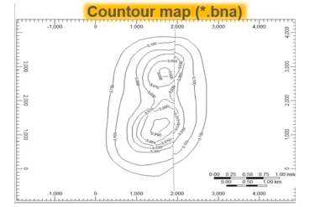

**Fig: Contour maps**

* Mesh Maps of 2D surface: Regular, orthogonal “grid” of data, value at each point, may contain fault lines and well locations.
* Rescue file: Some geostatistical and geological programs directly create a 3D grid with a grid system, properties of each grid like permeability, porosity, saturation etc. It can also include well paths and etc. We can make these geological models in following software.



**Fig: Different software where we can make geological models**

There are different ways we can fill in the properties of a grid system in Builder:

* Constant value: This is known as the core flood model, mainly used for homogenous model. We can use an average single value for most grids. We can do this under grid properties section of the Reservoir tab.
* Formulas: We use the formula manager to generate and assign new properties. For example, we can assign permeability as a function of porosity. Map files, array and geo-statistics are basically used in the formula manager.

Quality Control on Grid and Properties

We have a system in Builder which helps us to use irregular patterns of grid into use. That is why we have the system of Null Block and Pinch-out.

Null Block: In null-block we have the NULL keyword, depending on its value, the particular bock performs different functions. If the Null Keyword is 0 it acts as barrier and no flow through that block is considered. If it is 1 that means it is active and we consider its flow equation. The Null Block also has the key word – PV cutoff. PV cutoff means any value less than that the simulator will not consider further flow calculations. For example, 1m3, means any value less than that we will not consider flow calculations.

Pinchout Block: Similar to Null block we have Pinchout Array – this keyword controls flow along horizontal direction, with 0 and 1 having the same meaning. Pinchout-Tol this is minimum block thickness that needs to be considered to be considered active, otherwise it will be pinched.

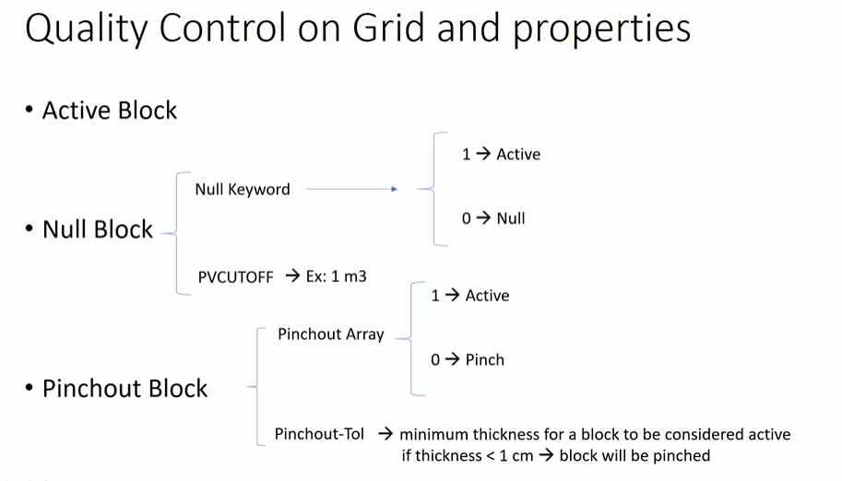

**Fig: Quality Control on Grid and properties**

Components Section

We are talking about PVT properties Bo, Eg, Rs, viscosity of oil, gas etc. We see a variation of these properties with pressure keeping the temp constant. Since we are considering black oil model we mainly require

* API oil gravity
* Reservoir Temperature
* Gas gravity
* Bubble point pressure

And using Standing Correlation or Vasquez and Beggs Correlation we obtain all the above properties variation with pressure. We can also obtain this PVT data using differential liberation and separator data, instead of correlations. This is more properly done in Win-Prop, and the data we obtain is more accurate.

The real question is why do we need these properties, because it will tell us how much oil and gas volume are there and applying flow equation, we can find how it will flow through the reservoir.

Rock-Fluid Section

Relative permeability curve and different phenomena can be modelled in Builder like:

* Multiple rock types and lithotypes
* Capillary Pressure and therefore the corresponding creation of transition zone
* Wettability Alteration, which could easily change the preferential flow of fluids
* Hysteresis
* Interpolation between Kr curves
* Adsorption
* End – point Scaling
* 3-point Scaling

In this section we can import the table of water saturation vs relative permeability (Sw vs kr curve) or we could use Corey’s correlation ( for 2-phase Kr), this can be done only if we know certain saturations like residual oil saturations and connate water saturations etc, this will generate the Sw vs kr curve.

If we want to do this in three phases then we can use the Stone’s 1st model, Stone’s 2nd model and so on.

Initial Condition

Original condition of the reservoir is defined here for example:

* Reservoir pressure at datum level (this is a point where we know the pressure)
* 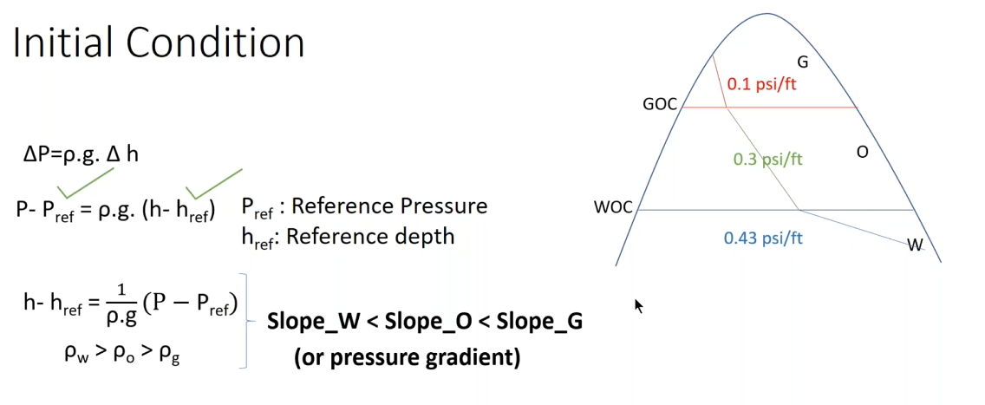Position of water and gas oil contacts

**Fig: What we can calculate with Initial Condition**

Now how does this help? If we know the pressure at a certain point, we can make it a reference and since we know the position of the water-oil and gas-oil contacts using the concept of pressure difference in terms of density and height we can find the pressure variations across the reservoir. Note that the curve is sharp because we haven’t considered capillary pressure effect.

Gravity Capillary pressure equilibrium calculations are performed to calculate all grid block pressure and saturations(Sw, Sg, So)

Wells and Recurrent

Well trajectories: Measured data of the trajectory can be imported by builder in different formats. It is basically the different wells, their names and the coordinates. We import a .wdb file.

Well Perforations: History of the perforated interval can be added to the trajectory of wells. We import a .perf file which tells us two things: 1. Measured depth starting and end plus 2. Depth range where cement is present in each well.

Well production/injection data: We can import simple production data if the columns in the file are properly defined like the columns of oil, water and gas produced per day. The file we import is a .prd file. Builder will convert this file that we produced on excel into .fhf file.

Well constraints and performance: It can handle well bore models, not always we have condition at the Bottom-hole. Maybe we only have surface pressure. So this helps in finding pressure form surface🡪perforation or the other way around. This we can do using VLP curve.

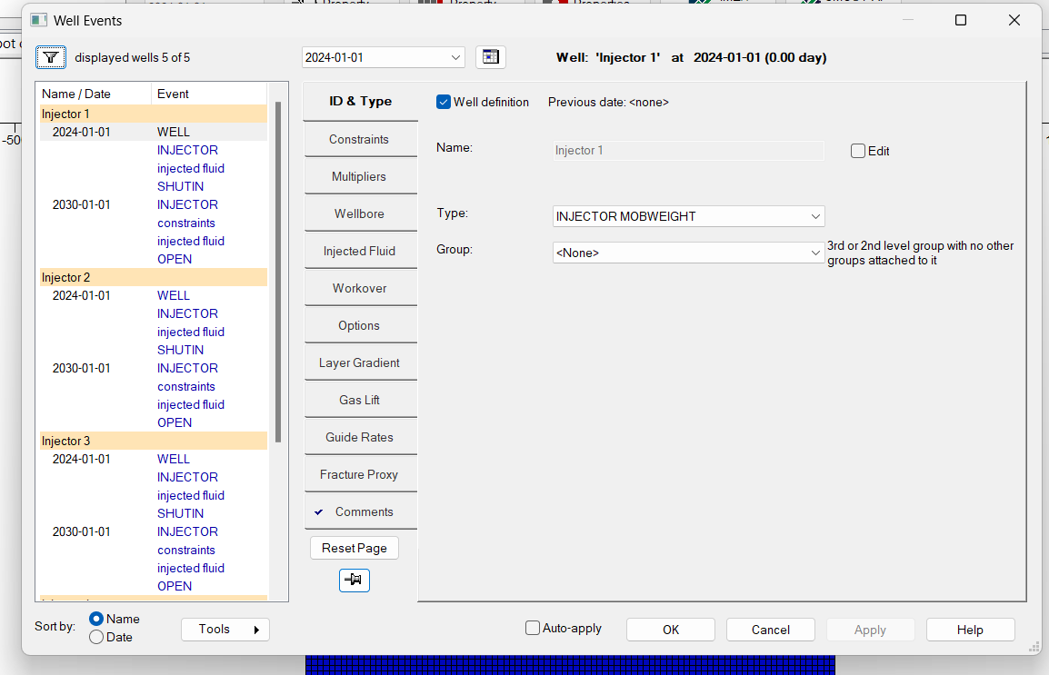

**Fig: Well Events**

I/O Control

How we want to view Simulation Results Output we can change here. We can change when to view and what to write, in the results of the Simulation.

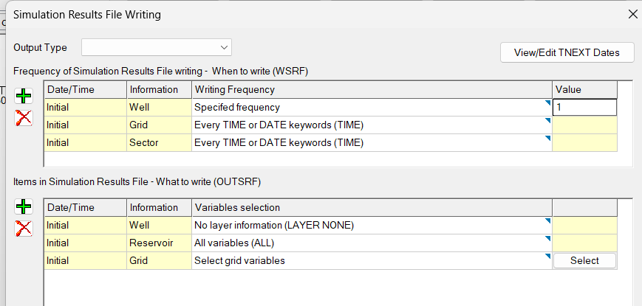

**Fig: Simulation Results File Writing**

As you can see in the diagram there is a section “When to write (WSRF)” which is for the frequency of output data. There is a “What to write (OUTSRF)” section which tells us about the data that you want to output.

Another thing we can do in this section is create a restart file. A restart file basically acts like a check point, a data file which stores the results of the last simulation you performed, this helps us by just restarting the simulation from where we left off instead of starting from the complete beginning. We can choose how many restart files and up to what time-stamp we want to store restart files.

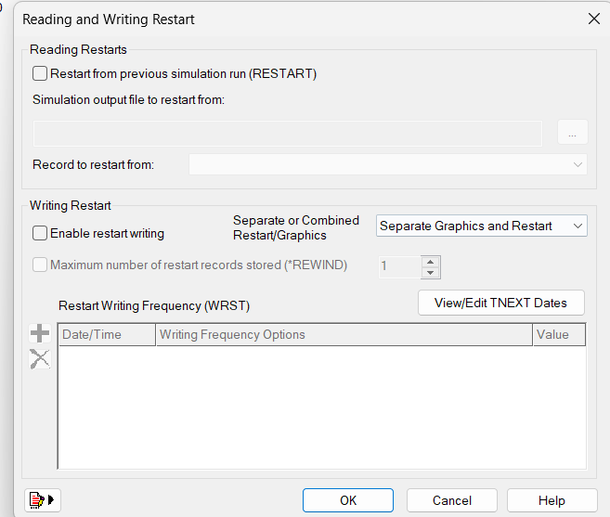

**Fig: Reading and Writing Restart**

We haven’t really delved into the intricacies of numerical section and the geomechanics section. Now that we have a general idea of the software, I performed two case studies.

1. Comparing different water-flooding patterns on a dummy homogenous reservoir

2. Looking at the affect change in permeability of water-flooding efficiency

Different recovery mechanism

**Primary Recovery**

In the initial stage of hydrocarbon production (known as primary recovery or primary production), natural reservoir energy drives hydrocarbons toward the wellbore. Some of this natural drive mechanisms are:

1. Depletion drive
2. Gas-Cap drive
3. Water drive
4. Gravity drainage
5. Combination drive

This natural differential pressure gradually declines as production continues. To maintain or increase production, artificial lift systems (like pumps) are used. However, primary recovery only extracts a small percentage (around 10%) of the initial hydrocarbons in place.

**Secondary Recovery**

In the second stage of hydrocarbon production—known as secondary recovery—external fluids (such as water or gas) are injected into the reservoir through dedicated wells. These wells communicate with production wells, maintaining reservoir pressure and displacing hydrocarbons toward the wellbore. It extracts an additional 15% to 40% of the original oil in place.

The two most common techniques are:

1. Water-flooding - Water is injected into the production zone to sweep oil from the reservoir into the well bore and also maintain reservoir pressure.
2. Gas injection - Normally, gas is injected into the gas cap to maintain the reservoir pressure.

These are operated until the production of water and gas from the production wells become very high and it becomes uneconomical to do so any further.

**Enhanced Oil Recovery**

It is an oil recovery enhancement method using sophisticated techniques that alter the original properties of oil. Once ranked as a third stage of oil recovery that was carried out after secondary recovery, the techniques employed during enhanced oil recovery can actually be initiated at any time during the productive life of an oil reservoir. Its purpose is not only to restore formation pressure, but also to improve oil displacement or fluid flow in the reservoir.

The three major types of enhanced oil recovery operations are

1. chemical flooding (alkaline flooding or micellar-polymer flooding)
2. miscible displacement (carbon dioxide [CO2] injection or hydrocarbon injection)
3. thermal recovery (steam flood or in-situ combustion).

The optimal application of each type depends on reservoir temperature, pressure, depth, net pay, permeability, residual oil and water saturations, porosity and fluid properties such as oil API gravity and viscosity. Enhanced oil recovery is also known as improved oil recovery or tertiary recovery.

Now let’s talk a bit in detail about waterflooding

Waterflooding in oil Reservoir

Waterflooding is a fundamental technique employed in the oil industry to enhance oil recovery from subsurface reservoirs. Its primary objective is to increase the overall oil-production rate by strategically injecting water into the reservoir. Here’s how it works:

In the initial phase of oil production, natural energy mechanisms—such as fluid expansion, gravity drainage, and solution-gas drive—facilitate the flow of oil from the reservoir rock to production wells. However, as the reservoir matures, these natural forces weaken, leaving a significant portion of the oil trapped within the rock matrix. This is where waterflooding comes into play.

1. **Voidage Replacement**:
   * Water is injected through dedicated wells into the reservoir. The injected water serves a dual purpose: it replaces the volume previously occupied by oil (hence the term “voidage replacement”), and it maintains reservoir pressure near its initial level.
   * By maintaining pressure, waterflooding ensures that the reservoir remains pressurized, which is crucial for sustaining oil production rates over the long term.
2. **Displacement Mechanism**:
   * As the injected water moves through the rock matrix, it displaces oil from the pore spaces. The water “pushes” the oil toward production wells, allowing previously trapped oil to flow and be produced.
   * The effectiveness of this displacement process depends on several factors, including the viscosity of the oil and the permeability of the reservoir rock.
3. **Secondary Recovery**:
   * Waterflooding falls under the category of “secondary recovery.” It complements the initial natural energy-based oil production.
   * While primary production relies solely on the reservoir’s inherent energy, waterflooding actively injects water to enhance recovery. It’s akin to giving the reservoir a gentle nudge—using water—to coax out more oil.
4. **Historical Context**:
   * Waterflooding has a fascinating history. In the early days of the oil industry, produced water (often saline or brine) was simply disposed of by dumping it into nearby streams.
   * However, in the 1920s, the practice shifted to systematically reinjecting produced water back into reservoirs. The Bradford oil field in Pennsylvania, US, played a pivotal role in developing waterflooding techniques.

Let’s talk about different pattern flooding operations that I will be working on:

1. **5-Spot Pattern**:
   * The **5-spot pattern** is a classic waterflooding arrangement.
   * It involves one central injector (usually water) surrounded by four production wells (oil producers) arranged at the corners of a square.
   * The 5-spot is straightforward and easy to implement, but it assumes uniform reservoir properties.
   * It works well in relatively homogeneous reservoirs.
2. **7-Spot Pattern**:
   * In the **7-spot pattern**, there are six injection wells (usually water) and one central production well.
   * The injector wells are positioned around the central producer.
   * The 7-spot provides better sweep efficiency than the 5-spot due to additional injectors.
   * It adapts well to reservoirs with moderate heterogeneity.
3. **9-Spot Pattern**:
   * The **9-spot pattern** expands further by adding four more production wells (for a total of nine wells).
   * The central injector is surrounded by eight producers arranged in a larger square.
   * The 9-spot offers even better sweep efficiency and works in reservoirs with varying geological properties

Case Study: Comparing different flooding patterns

Base Case:

I first developed a base dummy reservoir with the following properties:

1. Reservoir Section: We developed a grid with dimensions of 41 X 41 X 5, with each grid having 10m X 10m length and breadth and 2m height. So, the overall area of the reservoir was taken as 40 acres area and 10 m depth.

We used the quick pattern grid option to make a grid system, with a 5-spot injection, which contains 4 injection wells and 1 producer well.

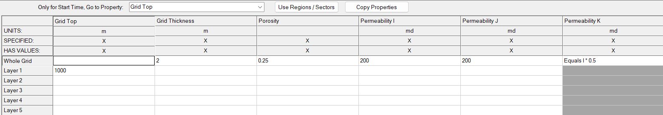 **Fig: Reading and Writing Restart**

This is how our array properties looked like, we considered the topmost layer of the reservoir to be at 1000m, grid thickness as 2m, and since it is a homogeneous reservoir, we had porosity of the entire grid as 0.25 and permeability in I, J direction to be 200md and along K to be 100md.

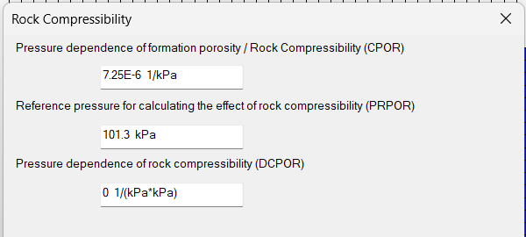

**Fig: Rock Compressibility**

2. Component Section: We have made a simple black oil model which used the information I gave to make a table of Bo, Eg, Rs, viscosity of oil and gas with pressure. The values which I used are given below.

* Reservoir Temperature: 50 C
* Oil density (API gravity) = 18
* Gas gravity (Air = 1) = 0.7
* Undersaturated Compressibility of oil = 5e-06 1/Pa
* Bubble point pressure = 12000 kPa

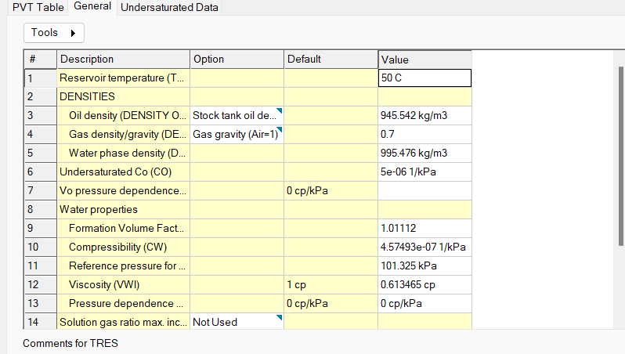

**Fig: Properties**

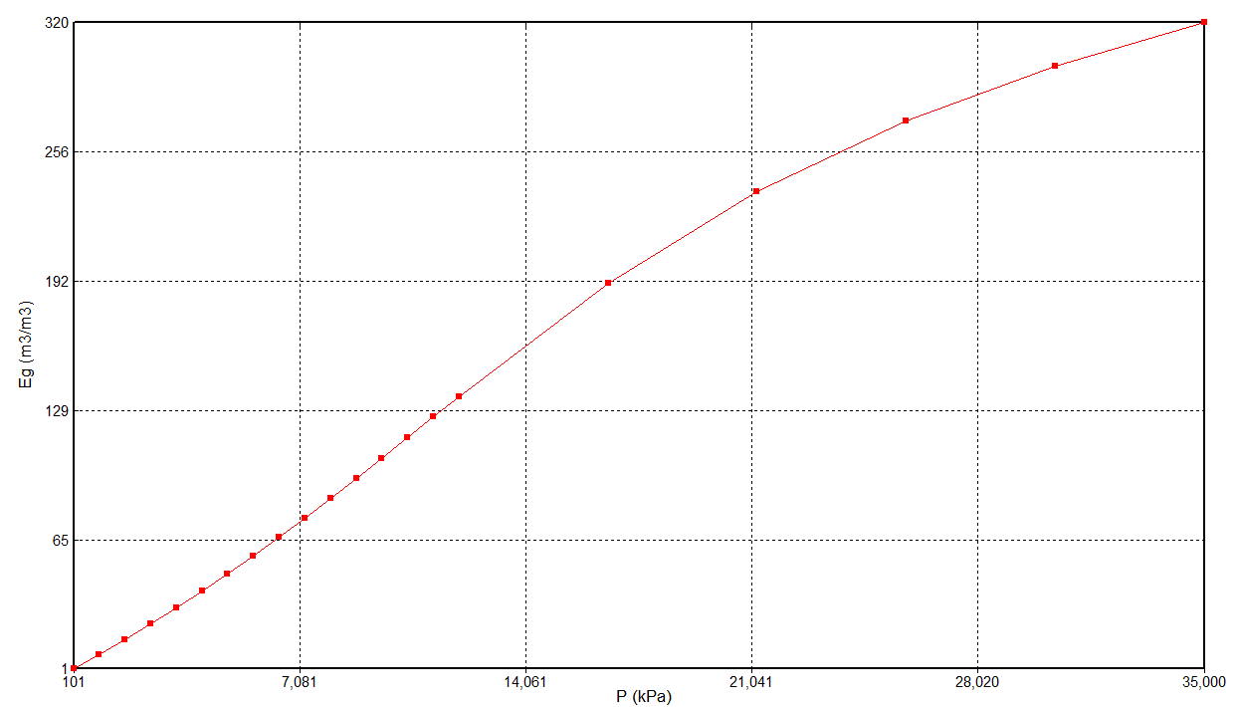From the above data we get the following graphs:

**Fig: Eg v/s P**

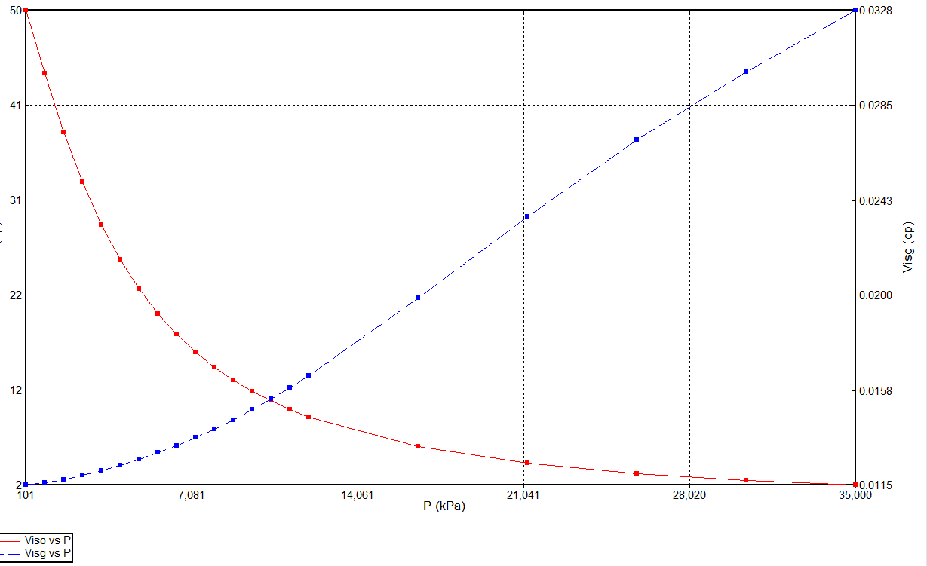

**Fig: Viscosity of oil and gas variation with Pressure**

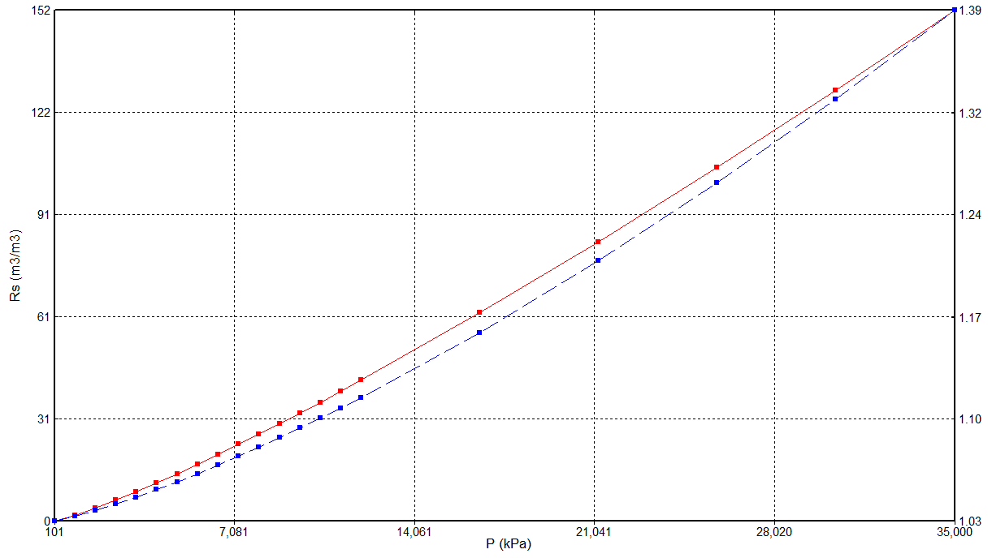

**Fig: Rs v/s P**

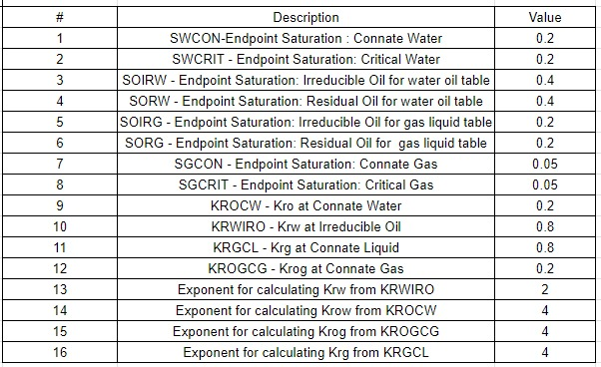3. Rock-Fluid Section: We used Corey’s correlation to make the relative permeability curves. The following data points, I used to make the relative permeability curves.

And using Corey’s correlation we find the following relative permeability relations with Sw with which we make the graphs.

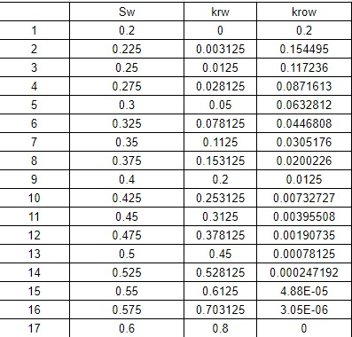

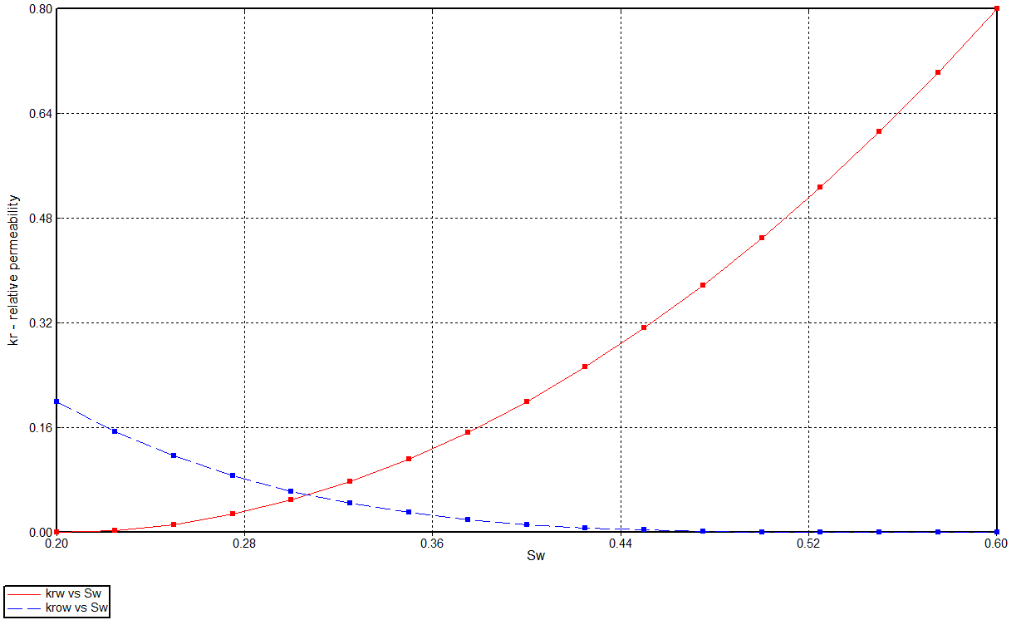

**Fig: Krw and krow v/s Sw**

4. Initial Condition: We had the following values as initial conditions.

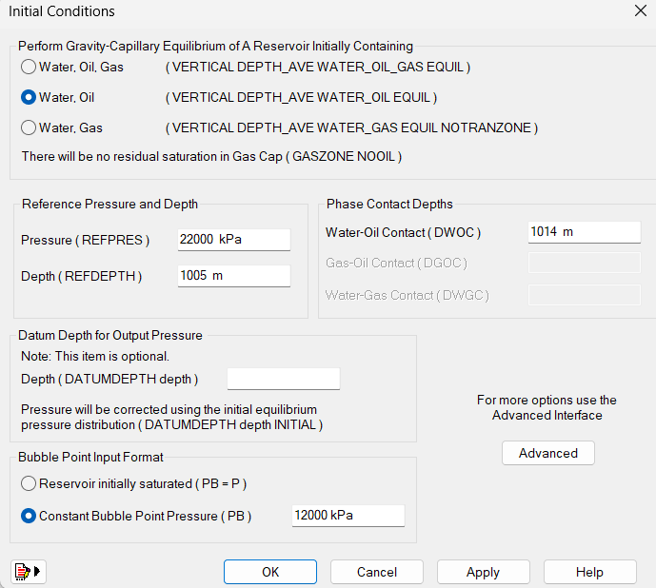

**Fig: Initial Condition**

As you can see the reference pressure was considered as 22000 kPa at a depth of 1005m. And the water-oil contact is taken way underground, below the 1010m mark up to which our reservoir extends. We have kept a constant bubble point pressure of 12000kPa.

5. Wells and Recurrent:

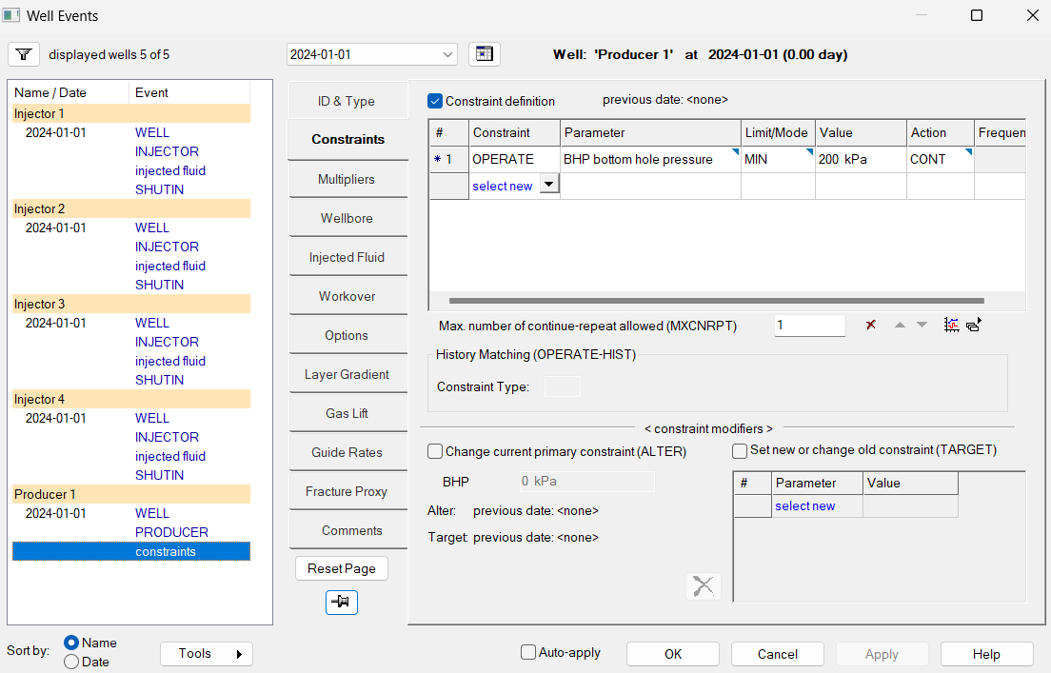As we can see in the above diagram, all the injector wells are shut in and only the producer well is working at 200 kPa minimum limit. This is usually set with keeping in mind the fact that the oil is able to be produced through the tubing.

**Fig: Well Events**

Now we simulated and found the following results and using the result application we found the following results:

1. Oil Production rate: The oil production gradually is decreasing as the reservoir pressure decreases. And if you look at the reservoir pressure decrease beyond 12000 kPa around that point the rate decreases below 20m3/day. This is important because we want to maintain that 20m3/day rate.

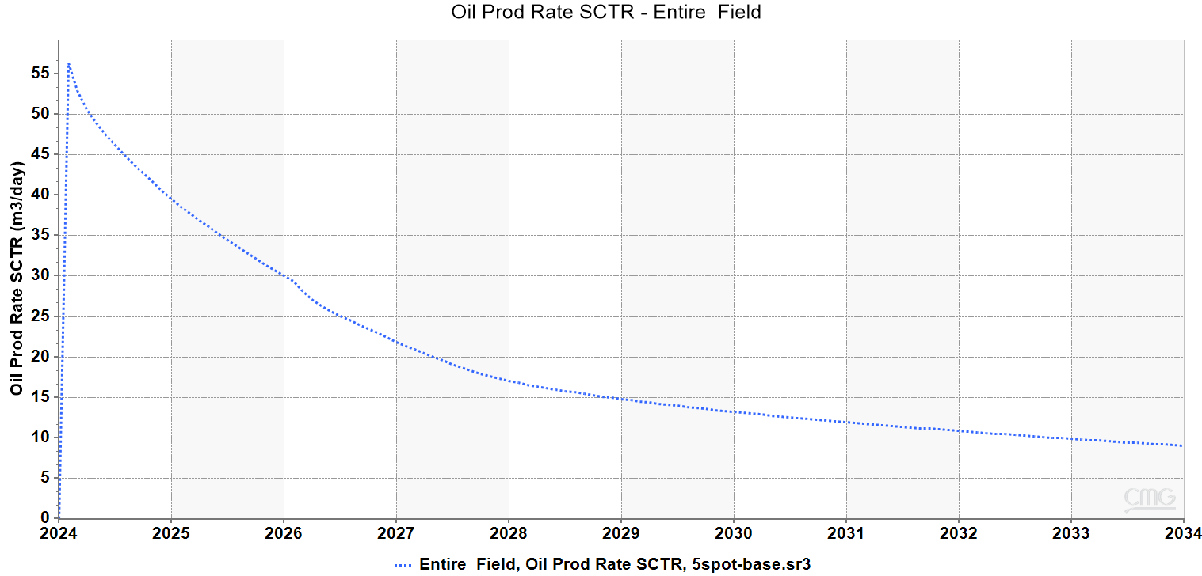

**Fig: Oil production rate**

2. Reservoir Pressure: Most definitely we can see that reservoir pressure is decreasing. The main thing to note is that the point it is just beyond bubble point pressure. We want to maintain the reservoir above the bubble point pressure since if gas begins to form inside the reservoir, then it will most definitely decrease production. Also, we don’t want to start injection process quickly either because that would lead to added costs. So, we need to find the correct time for water injection.

We can see that somewhere at the end of 2027 the pressure has decreased almost to bubble point pressure. So, this gives us an indicative to start Water-flooding at this point.

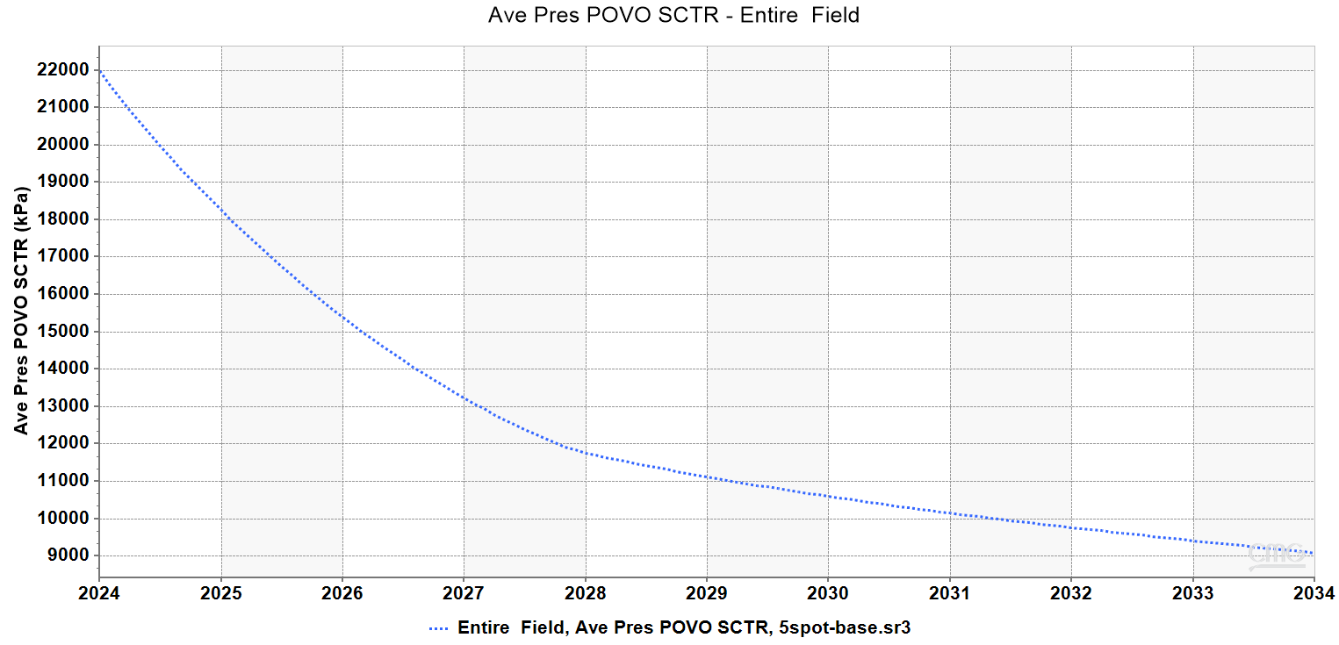

**Fig: Average Reservoir Pressure**

Grid Sensitivity Analysis

In Simulation we need to optimize the number of grids that we need to run the simulation but this value varies from reservoir to reservoir. I tested the base condition’s rate of oil production on different number of grids. I kept the height of the grids same that is 2m and 5 layers. On the areal front I kept the area same (that is 40 acres) and changed the number of grids. I kept a total of 5,11,21,41,47,51 and 81 grids and compared the results. In the diagram below you can see that 5grids (blue line), 11grids (orange line), 21grids (light green line) are far different from the rest. We can see that the base case (which has 41 grids, the orange line), 47, 51 and 81 grids system all have the same results.

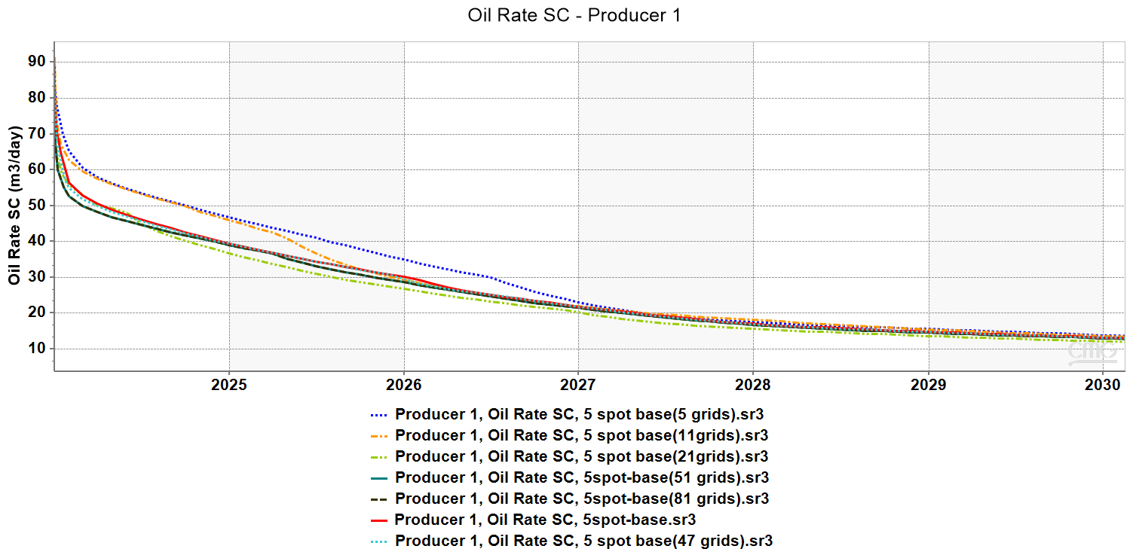

**Fig: Comparison of Oil Production Rate between different number of grids.**

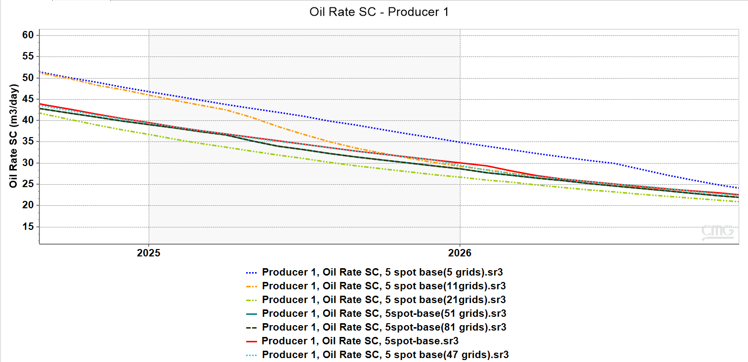

**Fig: zoom in of the previous picture**

Deciding time of water injection

To decide the best time for injection of water, we injected water at 5 different intervals and saw how the production rate varied.

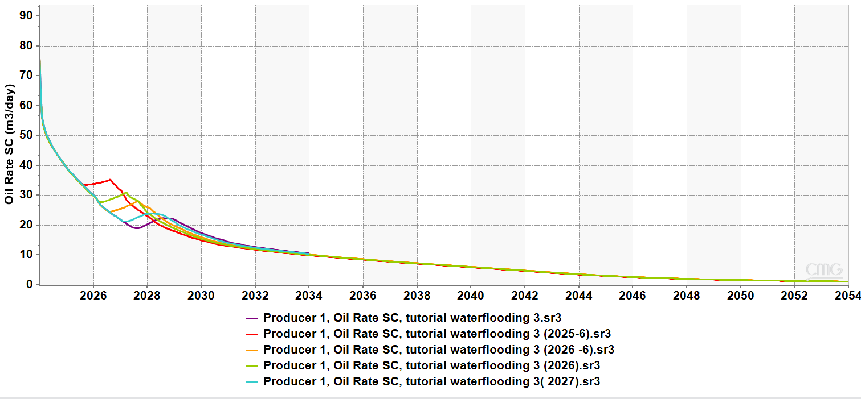

**Fig: Different time of injection**

This graph is clearly showing that there isn’t much difference in the longer run if we keep on injecting much before 2027 July, so this makes it clear to inject water at 2027 July, since it will help us save money.

Deciding how much should be injected

We are going to be following the simple concept of trying to maintain Reservoir Pressure. For that we decided to inject as much as water as oil was getting produced. This would enable us to maintain the VRR as 1. If we look at the graph of oil production rate, we can see that around 18 m3 oil was being produced at the time the reservoir pressure reached 12000kPa (bubble point). So, we decided to inject at a rate of 4.5m3/day per well (total 18 m3/day), 5m3/day per well (total 20m3/day), 7m3/day per well (total 7m3/day), 10m3/day per well (total 40m3/day), 30m3/day (total 120m3/day), 50m3 (total 200m3) and compared it to the results. In the table the legend is made keeping in mind the injection rate of one injection well.

Note: We are keeping the injection of each well constant and same throughout the simulation so that it becomes easier for us to compare the results among other patterns.

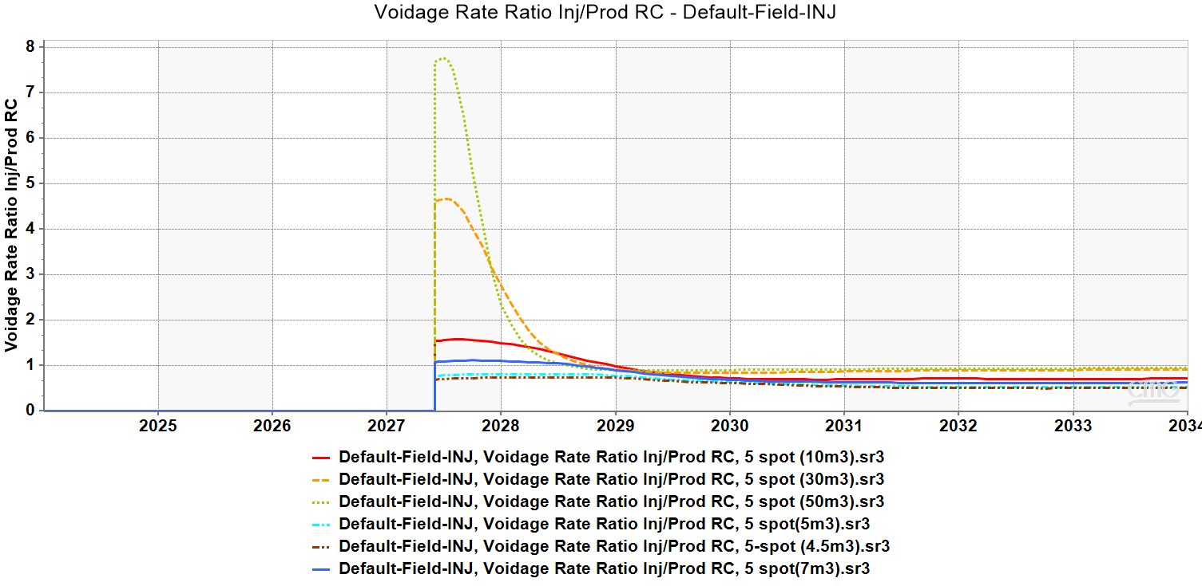

**Fig: VRR of different rates of injection**

We can see that 4.5 m3/day curve has very little VRR, the 5m3/day line has better VRR but still it remains less than 1. The 7m3/day, 10m3/day, 30m3/day and 50m3/day all have VRR more than 1, but 50m3/day and 30m3/day becomes overly excessive because the VRR becomes more than 5. This might lead to formation damage and also require excessive cost. The 7m3/day line and 10 m3/day line both have VRR just above 1. We decide to take 10m3/day which has a slighter more VRR because than 1 which over-compensates for some transport problems that might arise in the sub-surface.

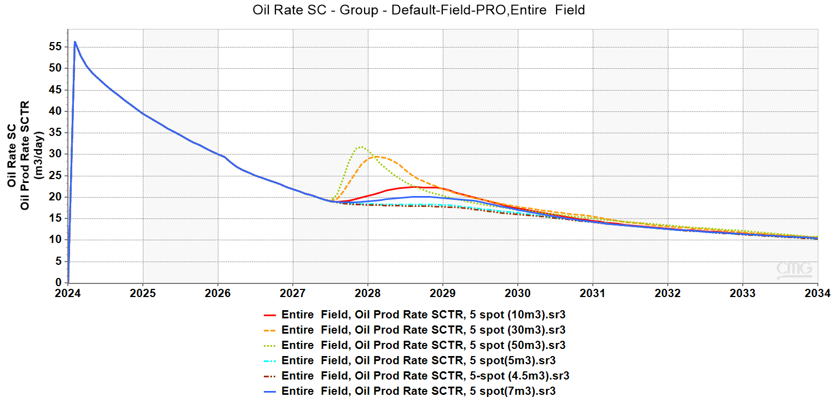

**Fig: Comparison of oil production rate at different rate of water injection**

Now as you can see the 50m3/day and 30m3/day do produce much more oil in the initial phase but eventually end up with as much as oil produced by the 10m3/day well. And we have talked about the fact that the extra production at this point is not worth the huge amount of water injection at the same time it might lead to formation damage and other complications.

**How much better is 5-spot as compared to normal production.**

Due to 5 spot injection at the rate of 10m3/day we get an extra oil production of 7780m3 (roughly 48934bbl extra oil) over the span of 6 years after injection. Now we can test with other spot patterns to check which has best results.

Comparing the efficiency of 5-spot and 7-spot pattern Flooding

Now we can observe that the oil rate has almost remained same for 5 spot and 7 spot patterns, because the sweep efficiency of 5 spot and 7 spot is almost same. The recovery factor of 7 spot is better than 5 spot but only by a small amount. This is the case that we observe when mobility ratio is same the sweep efficiency of 7 spot is around 75 % and that of 5-spot is around 72%.

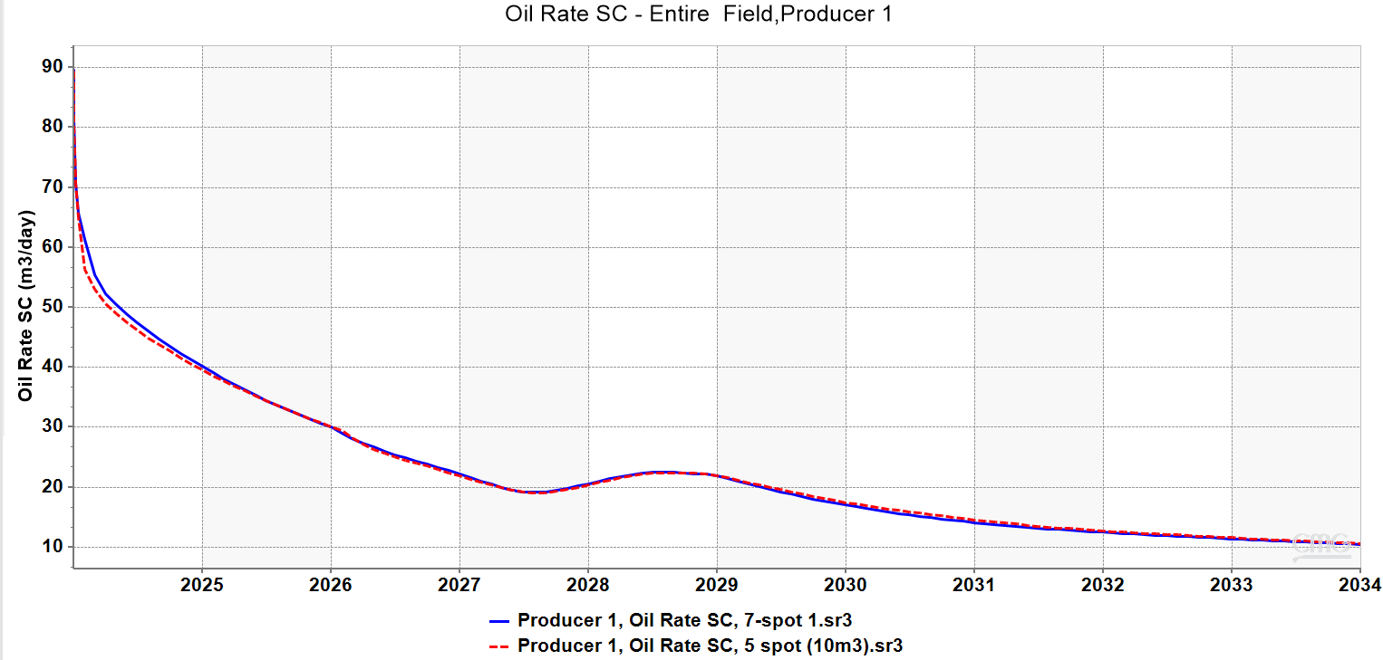

**Fig: Comparison of 5-spot and 7 spot pattern flooding**

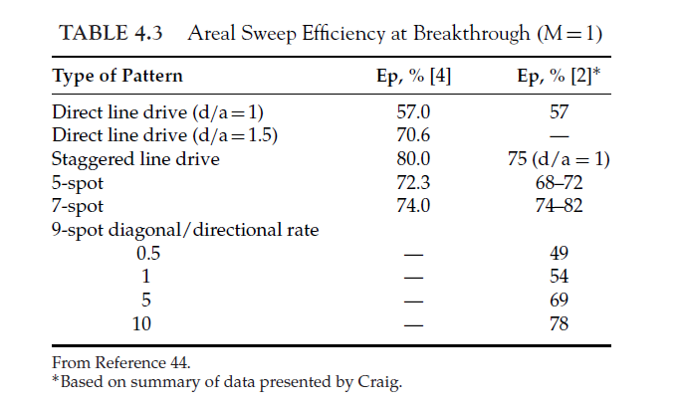

Conclusion: Comparing Sweep Efficiency of 5spot, 7spot and 9 spot patterns

As we know that if we change the diagonal/directional rate in a 9-spot pattern the sweep efficiency will be different. So that is why we considered the sweep efficiency of 5,7 and two cases of 9 spot pattern flooding.

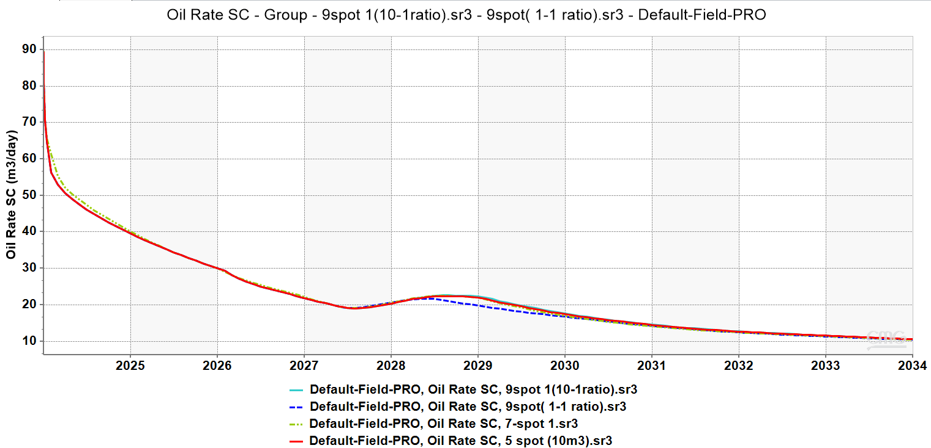

**Fig: Comparison of different pattern flooding**

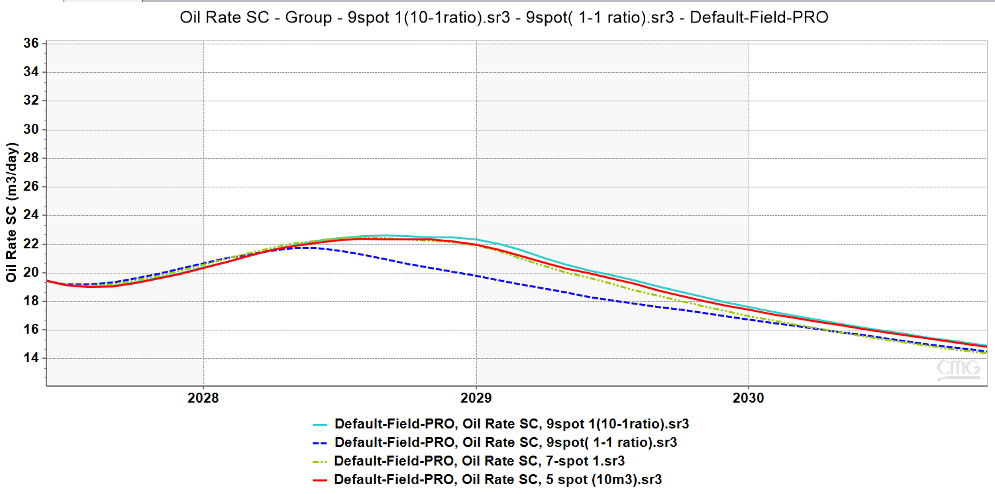

**Fig: Zoomed in picture of the previous graph**

So, what we understand is that the 9 spot (10-1 ratio) injection model has the highest accuracy, followed by 7 spot and 5 spot (giving almost similar results) and finally the 9 spot (1-1 ratio). This can be also further proved by the following or recovery rate graphs.

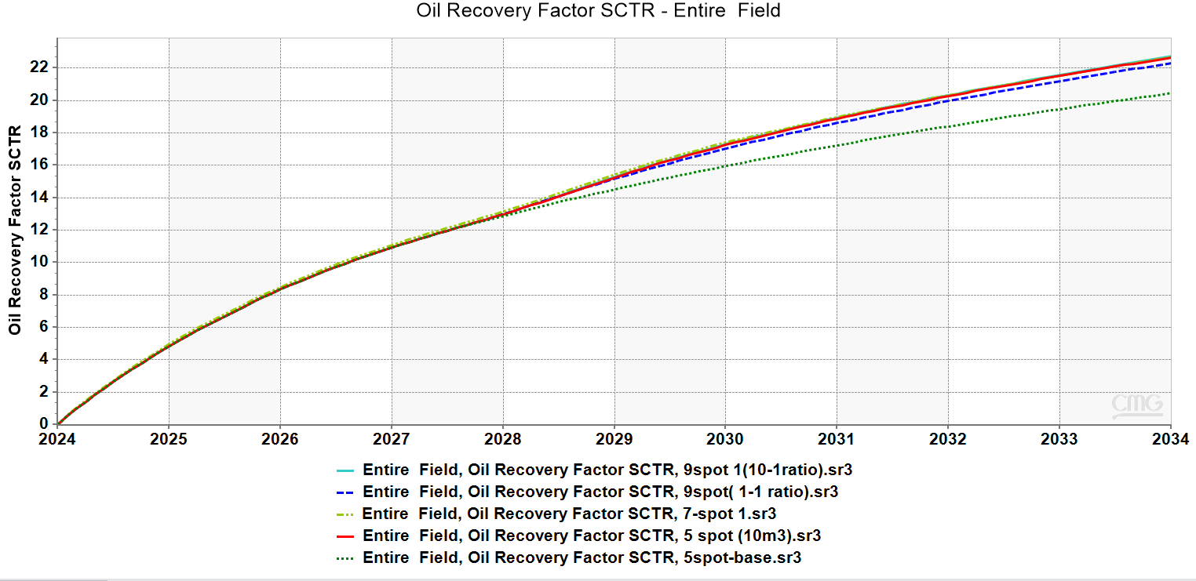

**Fig: Comparison of different pattern flooding oil recovery rate**

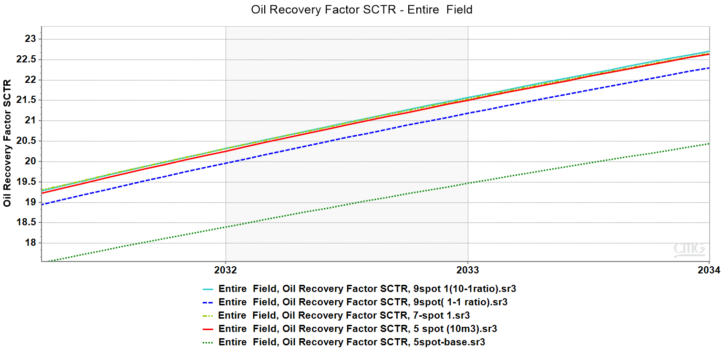 **Fig: Zoomed in picture of the previous graph**

We can see that lower most line is the base case without any waterflooding. Then we have the blue line which has lowest efficiency. The base case has a recovery of 70,534m3 after a period of 10 years. 9 spot (1:1 diagonal/directional) has 76990m3 after a period of 10 years that is an approximate more recovery of about 6000m3 of oil. The 5 spot and 7 spot has a similar recovery of around 78000m3 after 10 years and hence around 1200m3 more than 9 spot (1:1 diagonal/directional). The 9 spot (10:1 diagonal/directional) pattern has a recovery of 78440m3 after 10 years thereby having around 500 m3 more oil.

Conclusion

Thereby if we went on pure scale of percentage of recovery instead of economic basis, then 9 spot (10:1 diagonal/directional) pattern has the highest recovery. Whereas on the other hand if we do consider the economical constraints then 5 spot patterns have the highest economic benefit.